**TCCC Dev COE OnBoarding Process**

November 7, 2016

**Agenda for On boarding**

1. WS and Desktop allocation
2. Application Transition
3. Application Repository
4. Access Request
5. Application Setup

**WS and Desktop allocation**

* Communicate with the Capgemini COKE PMO for raising the request for the WS allocation and the desktop allocation for the new resource.

(Contact :- Hs Nandishwara , PMO)

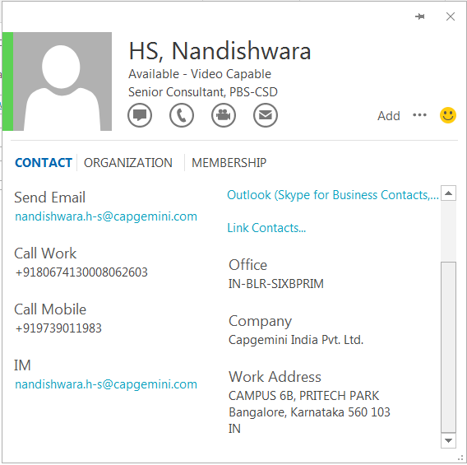

* Once the WS and Desktop allocation completed, request needs to be raised with the ITICS for configuring the desktop to make sure all the basic software have been installed to support the application.

Ex: - Cisco AnyConnect Secure Mobility Client, Required Browsers

* Before installing any software, developer should have Admin Access Privileges. For this raise a request from service desk portal and follow up with Manager to approve the same in the portal

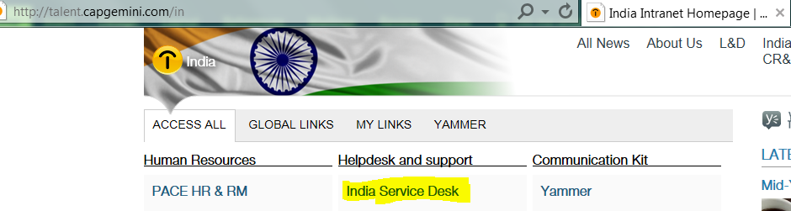

* Development environment setup, needs to install
* Contact TRO platform team ([lokesh.krishnappa@capgemini.com](mailto:lokesh.krishnappa@capgemini.com) / [ankit.prakash@capgemini.com](mailto:ankit.prakash@capgemini.com) / [arjun.pm@capgemini.com](mailto:arjun.pm@capgemini.com)) for installation help
* JDK 1.7_79
* Maven 3.x or later
* Take maven repository from any Mule resource.
* Anypoint Studio IDE latest and MuleRuntime 3.7.1
* Tortoise SVN Client and SVN plugin for Anypoint Studio IDE

**Application Transition**

* Schedule few sessions for the new resource to make them understand the business process and technical flow of the application.
* Application Transition KT recordings have been stored in the t-room SharePoint portal.
* Transitional slides have been stored in the t-room SharePoint portal.

**Application Repository**

* AOD Document
* KT recording
* Transitional Document
* SVN Application location

**Access Request**

* Capgemini T-Room Access and COKE ID creation

Provide the CORP ID and email details of the resource to the Account

PMO (refer top) for the Capgemini T-Room desired location access

* COKE ID creation
  + Manager needs to raise request in the COKE Portal for creating the COKE ID(i.e. TID) for the new resource.
* RSA Token Installation & VPN Setup
  + Once the TID created, the resource will receive the RSA file along with the instructions to setup. Make sure the Cisco AnyConnect installed in the resource machine.
* Coca-Cola T-Room Access
  + Onshore DM needs to be communicated with the resource TID asking for the access to the desired t-room location.
* SVN Access
  + Resource need to provide the KO Id and KO mail Id to DM for SVN access.
  + DM needs to be communicated for the specific SVN application repository.
  + Resource needs to take SVN CM (Configuration Management) training
* Plan view & Clarity Access
  + Resource N+1 needs to raise the request for creating the task for the resource in the Plan view with the COKE responsible person.
  + Once the task will be created the same needs to be communicated with Capgemini PMO for creating the same task in the Clarity portal.

Contact ITICS for installation of Cisco AnyConnect VPN and RSA Token software.

(Call ITICS: - 4004)

Contact Coke Support for RSA Token ID.

(Call Coke Support: - 00014046762246/8007292246)

(For Coke Chat Support: - <https://apps.ko.com>)

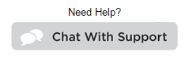

**Application Setup**

* eCMA Application Setup
  + Application file package.
    - Application CRX file will be provided to the resource with an overview of the process for creating the ChromeApps package and the installation procedure.
  + Configuring the application
    - The application config needs to be modified so that it will be pointing to the Q/Dev environment.
  + Loading the outlet for AOLarge and FSOP
    - A list of outlets provided for FSOP & AOLarge channel of eCMA Application. All the outlets belong to the Q/Development environment.
    - Below certificate needs to be installed before loading the outlets.
    - The resource needs to be in the COKE VPN while loading the outlets in the eCMA Application.
  + Tools for the Application
    - Google Chrome version 32 or higher.
    - Sublime Text Editor [For writing the CODE]
    - Postman [Testing the external APIs]